**Data 698 Final Research Paper.**

**Spatiotemporal Suicide Risk in USA: A Longitudinal Study 1968-2018.**

**Mikhail Groysman**

**5/3/2020**

Contents

Abstract. 2

Introduction. 3

Literature Review. 7

Hypothesis. 12

Data and Variables. 13

Statistical Methods. 15

Findings. 16

CDC Wonder. 16

CDC Mortality Multiple Cause-of-Death Flat File – 2018. 33

References. 33

# Abstract.

Suicide is an important issue not only for the families affected by it directly, but for the society as whole. The sign of seriousness of suicide is the fact that it is one of the top 10 causes of death in USA (National Institute of Mental Health, 2019).

The rate of suicide is drastically varying across space and time. From time prospective, the rates of suicide in USA increased from 10.7 in 2001 to 14.0 in 2017 (National Institute of Mental Health, 2019). Looking across states, we see the broad range of rates: from 8.3 in New Jersey to 25.2 in Wyoming (CDC, 2020). In addition, suicide rates vary across gender, age, and race (Spicer, 2000). Looking outside of USA, rates across of different countries are in broad range as well. Increases in suicide rates across of time and geographical outliers resulted in society looking deeper in the causes behind them. These causes are complex: mental disorders, substance abuse, and social factors as well as financial troubles.

This paper explores variables that correlate with increases/decreases in suicide rates. It looks at the behavior of the rates both across time and space. Specifically, from year 1999 to 2018. Geographically, the paper compares different USA states. It asks important questions, such as what factors play a role in suicide and can these factors be managed?

# Introduction.

Suicide is very deadly phenomena in absolute and in relative numbers. In 2018, it killed 47,173 Americans (National Institute of Mental Health, 2019). All around the world it kills over 800 thousand per year, which translates in 1.5% of all people dying from suicide (BMJ, 2019). Suicide is the 10th leading cause of death in USA (National Institute of Mental Health, 2019).

The complicating factor in understanding the suicide is that its rate is not uniform across time, geography, and demographics. In all three aspects, it varies widely.

Chronologically, USA had a favorable suicide rate in comparison to Western European countries, however it started to change somewhere in late 2000s. USA rate went up, while in the European countries it either dropped or stabilized (Guillaume, 2016). As American Foundation (Xu, 2020)for Suicide’s chart shows, there was a steady increase in rates since 2008 (AFSP, n.d.):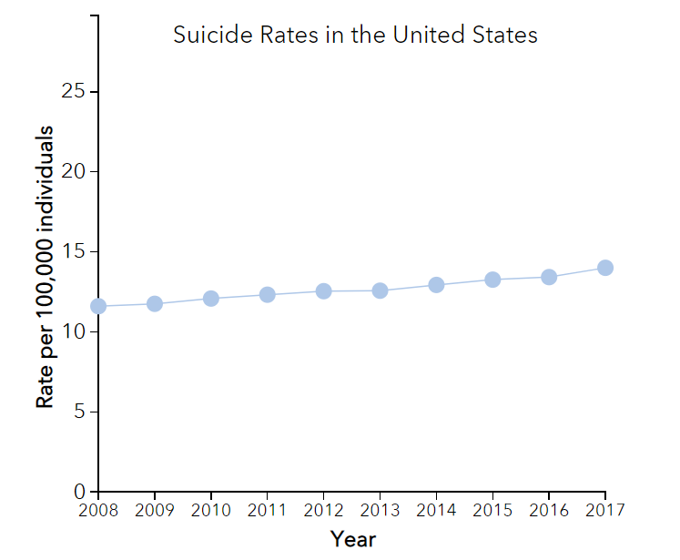

The latest available data for 2018 shows that suicide mortality rate continues to climb. It increased 1.4% to 14.2 (Xu, 2020).

Geographically, while the rate increase affected almost every state, some states got affected disproportionately. For instance, in Vermont suicide rates increased sharply – 84%, while in Nevada the rates dropped 2% since 1999 (CDC Wonder, n.d.).

It was long known that demographic factors correlate with suicide. Older people are more prone to suicide, as well as male. White and Native Americans have higher rates (Spicer, 2000).

Another set of factors are mental as well as substance abuse disorders: depression, bipolar, schizophrenia, alcohol and drug abuse (Bradvik, 2018). Of interest are unhealthy behaviors, such as alcohol consumption, lack of physical exercises, lack of availability of medical services, loneliness, availability of firearms, and sleep deprivation (Berardelli, 2018). Then, we have stress factors, such as unemployment, poverty, relationship problems, and psychological traumas (Gradus, 2010). PTSD among war veterans often leading to suicide is a serious problem in our society in the light of recent deployments in Middle East.

Cultural factors can play a role as well, for instance, acceptance suicide by society. And as our culture is rapidly changing, suicide rates might change as rapidly in any direction. Family history of suicide sharply increase the risk for an individual.

Another factor is residence: rural vs urban as well as population density. People, who live in isolated, low density areas, might be more prone to loneliness, which might play a role in their decision to commit suicide. A marriage status is also a predictor, as married are less likely to commit suicide. Genetics is playing a big role too. When a person decides to commit suicide availability of means to do it becomes very important. One thing that plays a role is high accessibility of guns in some US areas.

New research in traumatic brain injury sheds additional light on the causes of suicide, with indication that TBI increases the risk (Madsen, 2018). Higher suicide rates in mountainous areas of USA caused a question of association between altitude and suicide rate.

And then, we have accuracy of death cause reporting, as often suicides are underreported (Toleffsen, 2012).

Media outlets sometimes report suicides in sensationalized way (McTernan, 2018), which could potentially trigger copycat suicides spikes. Another interesting observation is that suicides are highly seasonal. It reflects in weekly as well as annual patterns. Increases correlate with holiday season.

What makes suicide unique is that it seems to be immune to improvements in medical care. While, we are getting better at treatments of such deadly diseases as cancer, heart attacks, and stroke, we fail to prevent people from committing suicides. For instance, in 2018, most major death causes (heart disease, cancer, injuries, COPD, and others) saw a drop which contrasts with an increase in suicides (Xu, 2020).

As we can see, suicide is the complex phenomenon, which is not fully understood and requires a broad look at different factors.

One such attempt was done by a group of German researchers who looked at behavior of suicide rates across German federal states during over many years. They were able to look at number of general practitioners, income, population density, unemployment, and depression (Helbich, 2017). The goal of this paper is to reproduce similar research for American states for 1999-2018.

Difficulties of doing suicide research are something that I know personally. In my first semester, in Fall 2018, my final project was on the discrepancies in suicide rates across of American states. My realization was that we lack quality data. Due to the complexity of phenomenon, correlations are often week. However, suicides are not going away on their own, and we need to continue researching them to offer insights into prevention.

By looking at suicide from 3 angles - chronological, geographical, and demographical - I will develop a more comprehensive picture of suicide.

So, the questions to answer are:

* How have suicide risks changed over time?
* What factors are associated with suicide rates?

# Literature Review.

Practically daily, new scientific papers are published on suicide. Many of them try to quantify different aspects of suicide. However, many questions are still not resolved. This study tries to resolve at least some of these questions (McTernan, 2018).

As Robert Gibbons emphasizes in his paper, suicides are difficult events to study. Despite being widespread (more people die from suicides than from either homicides or AIDS), they still rare statistical events. Suicide ideations, while are more common, are not a good proxy (Gibbons, 2013). The author of this paper also encountered issues of getting complete up to date death information, due to the suppression of deaths records with fewer than 16 deaths by CDC to prevent privacy issues.

Spatiotemporal research of USA using Poisson identified suicide clusters such as Montana, Alaska, Wyoming, the states that are known for abnormally high suicide rates (KTL, 2018). However, the goal of this paper is to do more than to just pinpoint problematic regions. As the German’s spatiotemporal research, I would like to identify relationships or lack of it between the risks and suicides.

The German paper deals with issue of the increase in suicide in the country. It covers time period from 2007 to 2011. The researchers state the acknowledged fact that reasons behind the increases in suicide are not well understood. The study notes that different German regions behavior differently. It also gives concrete recommendation such as to concentrate preventive measure on vulnerable risk populations (Helbich, 2017).

As I have mentioned in the introduction, USA suicide rate increase in recent years is contrasting with a drop in European rates (Guillaume, 2016). The European rates dropped on average almost 23% from 1990 to 2010. The drop was significant in youth and older populations, and much less pronounced in middle aged. This dynamic is the same as in USA, where middle aged are the most affected.

There was a research into influence of alcohol abuse on suicides (Pompili, 2010) (Lamis, 2012 ). As the first paper states, alcohol is a risk factor for suicide and more researches need to be allocated in prevention, specifically among vulnerable subpopulation. Other countries experience high suicide rate due to alcohol abuse, specifically Eastern Europe (Landberg, 2008). Also interesting is that Russia which has experienced both high rates of alcohol abuse as well as very high suicide rates for the last 50 years (Russian Statistical Yearbook, 2018) (Global status report on alcohol and health, WHO, 2011). And as alcohol consumption has dropped, suicide rates went down as well (Rocha, 2019).

It appears that many researchers have looked into pinpointing alcohol abuse as a suicide factor. However, my goal to quantify the relationship as well as quantify role of alcohol in increase in suicide rates in USA in the last decade and as a factor explaining drastic difference in suicide rates across the states.

Study in Portugal attempted to connect specific geographical regions with other suicide risks and identify problematic regions. It asks a very important question: can we develop risk map for suicide rates? As a results, it identified the following correlations: “…being a foreigner (OR 26.64; 95% CI 13.15-53.97), having no religion (OR 8.65; 95% CI 4.62-16.19) and having lower levels of education (OR 1.20; 95% CI 1.09-3.64) are associated with a higher risk of suicide in Portugal.” (Rocha, 2019)

Another study found positive correlation between use of benzodiazepines and suicide. The study used binary logistic regression to evaluate the association. Interestingly, benzodiazepines as alcohol are nervous system depressants (Cato, 2019).

Methods of suicide can indicate availability of means and other factors, CDC published study shows that suffocation increased sharply in the last 18 years outpacing suicides by means of firearms and poisoning (Curtain, 2020). The increase applied both to males and females. Interesting finding since there is a lot of focus on role of firearms and drug related poisoning in suicides, while role of suffocation might be underappreciated.

Heavy Episodical Drinking (HED) could be a comorbidity factor for patient with suicide ideation, as the study indicates. It looked at patient with HED and suicide ideation for the last 5 years. Again, the study used logistic regression to evaluate the results (Richards, 2020) . This study will apply linear regression instead.

Another study looked at suicides in District Columbia, which is an anomaly in USA in sense that it has much lower rates than the rest of the country. The study found that “…ethanol (26.4%), antidepressants (20.1%), opioids (14.9%), and benzodiazepines (12.9%) were the drugs most frequently involved, although the finding of no drugs was most common (33.7%).” We can see that ethanol and benzodiazepines were involved in the suicides (Cuchara, 2020). It agrees with this study hypothesis that alcohol is a big player in suicides.

The World Health Organization is a great source of quality information. A study based on this data found correlation between suicides and alcohol consumption as well as unemployment rates (Ilgun, 2019). The study also noted that suicides have multiple complex causes. Again, the view of suicides as complex phenomena that has many different driving factors aligns with this study.

The unusual meta-analysis study linking suicides to ecology found dose dependent correlation with levels of lithium in drinking water. As study indicates, more research is needed to confirm the findings (Barjasteh-Askari, 2019). Unfortunately, due to lack of reliable data, this fascinating topic won’t be analyzed in this paper.

Machine learning becomes a widely used tool in medical research. One study used CNN and gradient boosted trees to predict death from suicide using administrative healthcare system data (Sanderson, 2019). This study pinpoints a major limitation, which is common for suicide research, which is the lack of many important predictors in available data. This limitation was a struggle for the author as well.

Another interesting study found a statistically significant decrease in suicide rates among these with high school education or less for each dollar increase in minimum wage (Kaufman, 2020). This research will look at social economic factors as well.

Study in Korea found positive association between long working hours and suicides (Lee, 2020). Interesting finding, since USA has one of the longest working hours in the world.

Reliability of data is always a major concern in suicide studies. A study which compared VA Mortality Data Repository suicide data with death certificates found a major discrepancy (Hoffmire, 2020).

Substance abuse disorders are recognizable risk factors for suicides. A study evaluated the risk by type of SA disorder and found that women are more at risk. It also found that multiple SA disorders in the same person increase risk of suicide. Even smoking addiction will increase risk of suicide. The study mentioned above addresses the focus of this paper – influence of substance abuse and specifically alcohol onto suicide rates (Lynch, 2020).

A study from Japan revealed that an increase in government spending to stimulate economy helped to decrease mortality from suicide (Matsubayshi, 2020).

Another study from Japan attempted to identify geographical suicide clusters as well as factors leading to an increase in suicides. For men, unemployment was a big factor, while for women, health problems were a factor (Yamaoka, 2020).

An effort to use machine learning to predict suicides showed its usefulness. It also displayed its limitations, such as low accidents of suicide attempts to draw strong conclusions. However, mental diseases as expected were good predictors of suicide attempts (Zheng, 2020).

Interesting study that looked at suicides vs thoughts of suicides pinpointed high tolerance of pain and lack of fear of death as factors which lead one to move from just thinking to committing suicide (Klonsky, 2017).

# Hypothesis.

In the prior section, the German paper on spatiotemporal suicide risk was mentioned. My goal is to apply similar methods to USA.

USA is even more diverse country than Germany, and different regions (state, county), subpopulation (gender, race, age, Hispanic status, urban vs rural) might show unique linear and no-linear trends, both positive and negative, in regard to suicide when it comes to healthcare utilization (annual check-ups), median household income, population density, unemployment, depression, mental health status, sleep status, binge drinking, and other risks.

# Data and Variables.

The data sources are:

* CDC Wonder (Wide-ranging ONline Data for Epidemiologic Research). It contains mortality data for the last 20 years (1999-2018) on county level. The data is broken down by region/state/county, age, gender, race, Hispanic ethnicity, year, and cause of death (CDC Wonder, n.d.). It contains high level details on all suicides committed in the 20 year period. The data presented in absolute values, as crude death rate, and as age-adjusted rate as well. The tool provides 95% confidence interval to evaluate reliability of data.

ICD10 codes for suicide are X60-X84. Due to privacy concerns some detailed mortality data is masked (9 or fewer deaths).

* 500 Cities. A collaborative project between CDC and Robert Wood Johnson foundation. It contains surveys, recording health behavior for 500 largest cities across USA (500 Cities: Local Data for Better Health, n.d.). Behavior statistics includes binge drinking, annual check-ups, mental health status, and other risk factors.
* SAMHSA (Substance Abuse and Mental Health Services Administration) Surveys (SAMHSA, n.d.).
* Census Community Survey (American Community Survey, n.d.).
* Census (Census, n.d.).
* USA Bureau of Labor Statistics (BLS, n.d.).

The variables are:

* CDC Wonder:
  + Location: state/county. The variable allows more detail geographical look at suicide rates.
  + Cause of death (suicide, cirrhosis). Main cause of death of interest is suicide itself, however cirrhosis is of interest as well, as it could be used as a proxy for alcohol abuse.
  + Urbanization. The variable allows to differentiate urban and rural areas, which are known to have different suicide rates.
  + Age. The variable is known factor in suicide, as suicide rates vary widely by age.
  + Gender. The variable is known for association with suicide rates. Male rates are typically higher than female rates.
  + Hispanic Origin. The variable is known for association with suicide rates. Hispanic typically have lower rates than non-Hispanic.
  + Race. The variable is known for association with suicide rates. White and Native American typically have higher rates.
  + Year. The variable allows to look at rates chronologically.
* 500 Cities:
  + State/City. The variable allows more detail geographical look at suicide rates.
  + Mental Health Status. The variable is known factor in suicide, as suicide rates for people with mental illness are typically higher.
  + Annual checkup. The variable is known factor in suicide, as suicide rates for people with poor access/utilization of medical services are higher.
  + Binge Drinking. The variable is possible factor in suicide, as suicide rates for people who abuse alcohol are higher.
  + Smoking Status. The variable is possible factor in suicide.
  + Physical Inactivity. The variable is possible factor in suicide.
  + Obesity. The variable is possible factor in suicide.
  + Sleep Status. The variable is possible factor in suicide.
* SAMHSA (Substance Abuse and Mental Health Administration survey)
  + Depression rates. The variable is known factor in suicide, as suicide rates for people with depression are higher than for non-depressed people.
  + Substance disorders. The variable is known factor in suicide, as suicide rates for people with substance abuse disorders are higher than for people without.
  + Alcohol disorders. The variable is known factor in suicide, as suicide rates for people with alcohol abuse disorders are higher than for people without.
  + Other mental disorders. Potential factor.
  + Suicide ideation. The variable is known factor in suicide, as suicide rates for people with ideation are higher than for people without.
* Census Community Survey
  + Median household income. Low income plays role in suicide.
* Census
  + Population density. Population density is a potential factor in suicide.
* USA Bureau of Labor Statistics
  + Unemployment rate. Unemployment rate is a potential factor in suicide.

# Statistical Methods.

First, extensive descriptive statistics will be performed to understand relationship between different variables to identify potential outliers and multicollinear variables (Spriestersbach, 2009). Visualizations and graphs will be used to make dependency between variables easier to understand.

To understand geographical differences between states and counties, Moran’s I test will be used. The test often used for health variables (Li, 2007).

The models, I will use, are linear regression and random forest, as my model has the quantitative dependent variable (the rate of suicide) (Schneider, 2010). To select the best variables, I will apply LASSO (Fonti, 2017). I will also apply specific space-time models, such as Bayesian space-model regression, as it attempts to address changes over time, instead of assuming the risks are staying constant. I will apply Neural Network to my data to see if it would be superior in modeling the data.

# Findings.

## CDC Wonder.

CDC wonder provides mortality data from 1968 to 2018. It allows us to see changes in suicide mortality in its “crude, not age adjusted form:

Suicide rate went from 10.7 in 1968 to 13.0 in 1977, raising again in 1986 to 12.9 and then dropping to 10.4 in 2000. Since 2000, rates were going up reaching 14.8 in 2018 (increasing 38% since 1968 and 42% since 2000).

If we adjust for age, picture will slightly change:

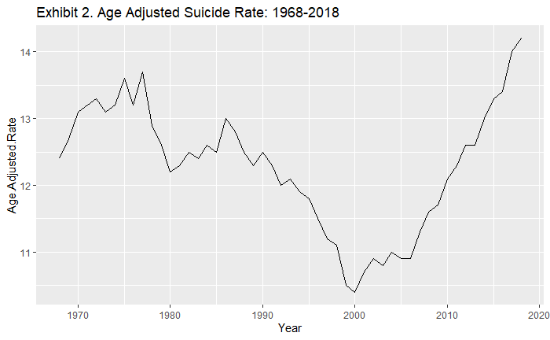

Suicide rate went from 12.4 in 1968 to 13.7 in 1977, raising slightly in 1986 to 13.0 and then dropping to 10.4 in 2000. Since 2000, rates were going up reaching 14.2 in 2018 (increasing 15% since 1968 and 37% since 2000). The improvements in suicide rates in late 80th and 90th were lost in the last 18 years.

If in addition to adjusting for age we also adjust for race, we again get slightly different picture (2000 race breakdown was used):

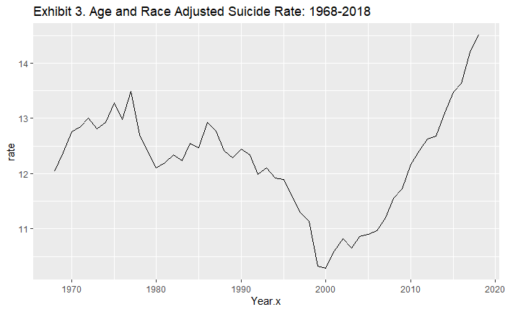

Suicide rate went from 12.0 in 1968 to 13.5 in 1977, raising again in 1986 to 12.9 and then dropping to 10.3 in 2000. Since 2000, rates were going up reaching 14.5 in 2018 (increasing 21% since 1968 and 41% since 2000).

All 3 charts, in the end, show that suicide rate has improved, but the improvement was reversed.

Different age groups behaved differently over the years (chart was smoothed):

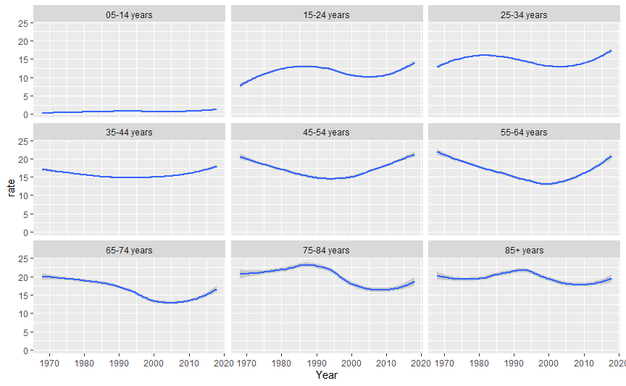

“15-24” and “25-34” groups look similar to each other and to overall suicide trend, even though they reached the lowest rate around 2005, not 2000. “35-44”, “45-54” and “55-64” groups also display similarities to each other – they did not experienced spike in late 70th. Again, “75-84”, and “85+”, both peaked in late 80th or early 90th.

It is a known fact that suicide rate differs by gender: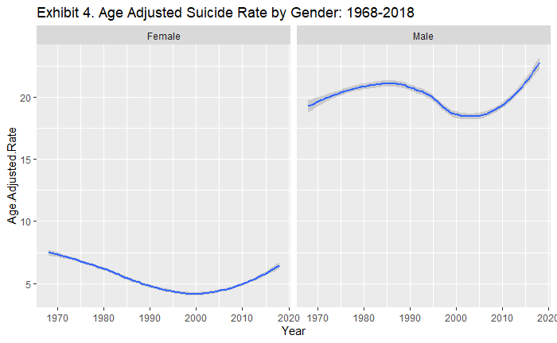

Female age-adjusted suicide rate as of 2018 has not yet reached what it was in 1970th, while male rate did not experience as a big improvement as female and as of 2018 is the highest it has ever been in the last 50 years. Females experienced similar patterns of suicide rate across all age groups, while male have 2 distinct patterns (Exh5). One male pattern (“25-34” and “35-44”) is similar to female changes in rate – drop to 2000 and then increase, while another pattern experienced a peak in late 80th and then zigzag to the next 30 years.

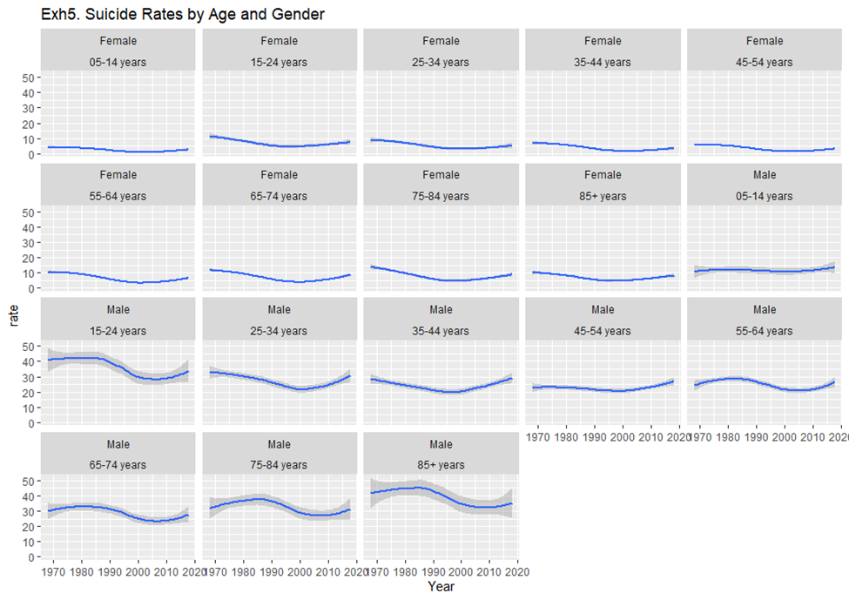

Methods of suicide has changed too over last 50 years (Exh6). Guns peaked around 1990, while share of hanging was increasing for last 30 years. Gases have seen a sharp drop. Poisoning were going up and down.

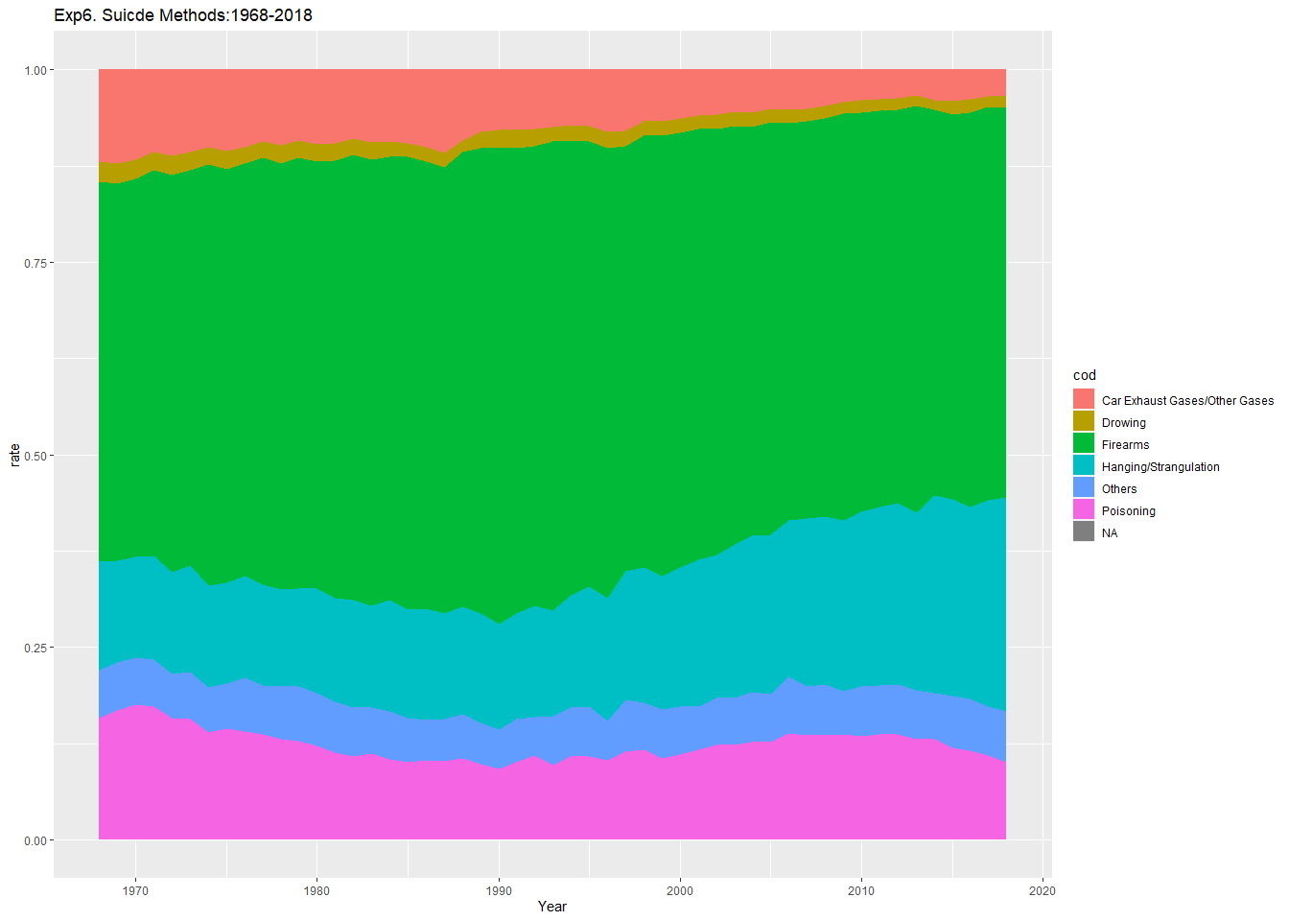

Different age groups use different methods and have experienced different changes:

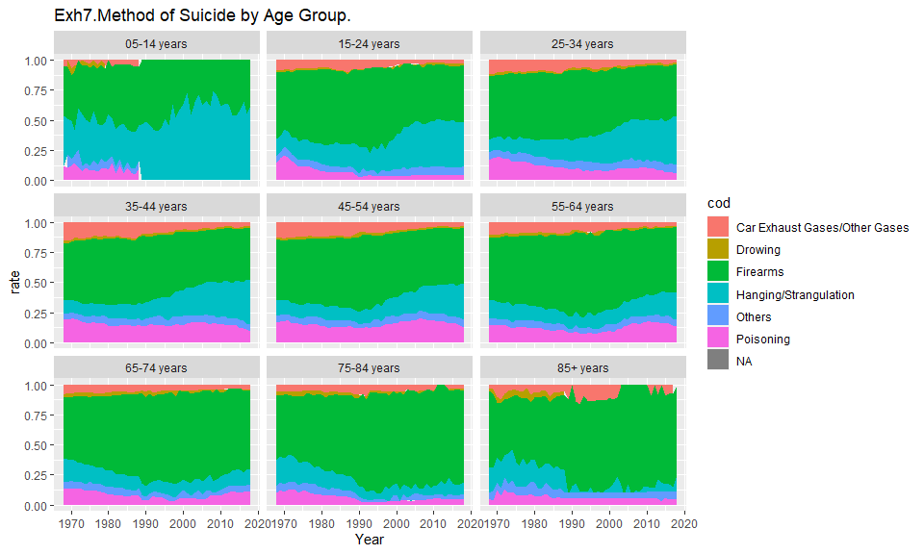

Interestingly, “65-74”, “75-84”, and “85+” groups have experienced an increase in gun method, while “15-24” group saw a sharp decrease in gun suicides.

Methods also differ by gender:

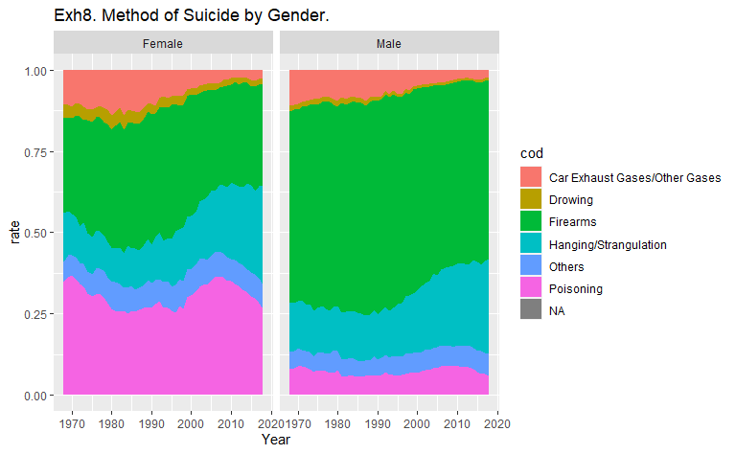

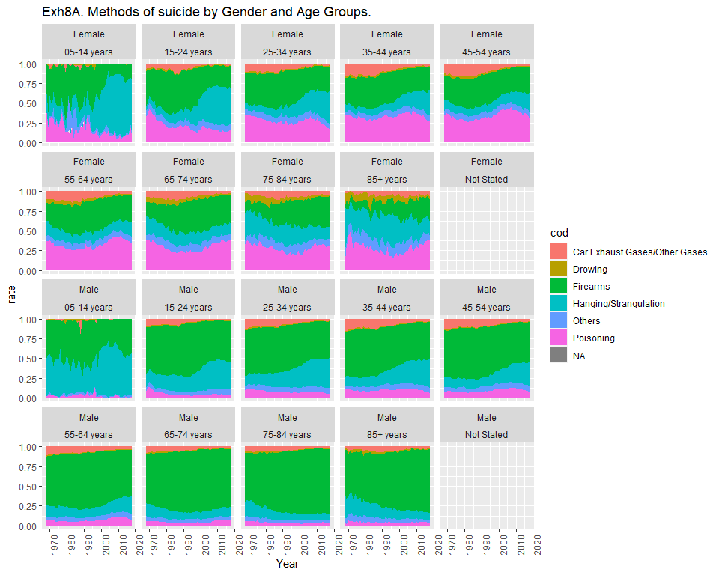

Poisoning is more common among females, while gun suicide is more common among males.

Suicide rates are differed by race as well (Exh9, Exh10). Interestingly, African American suicide rate bottomed at around 2005, while whites at 2000.

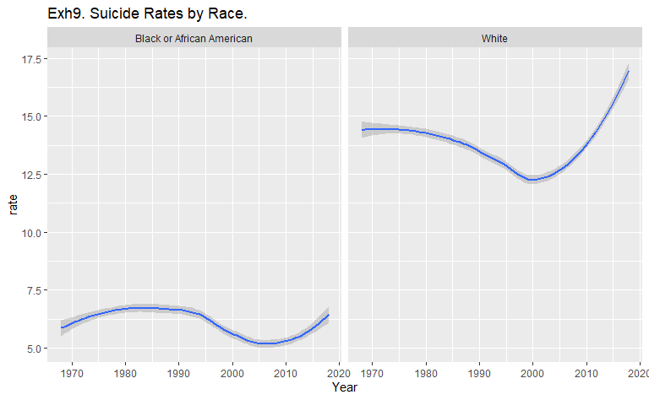

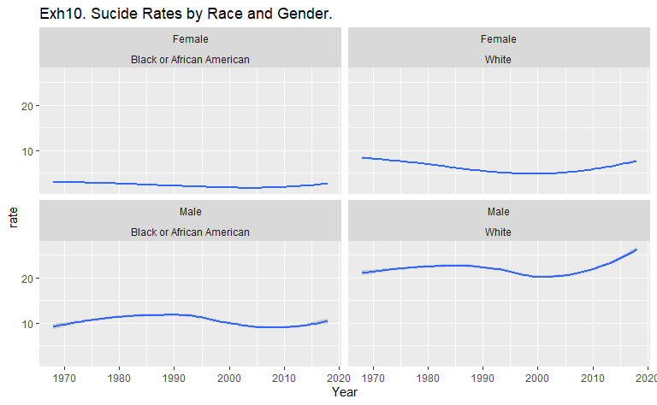

Different generations have experienced different pattern of suicides during their lifetime.

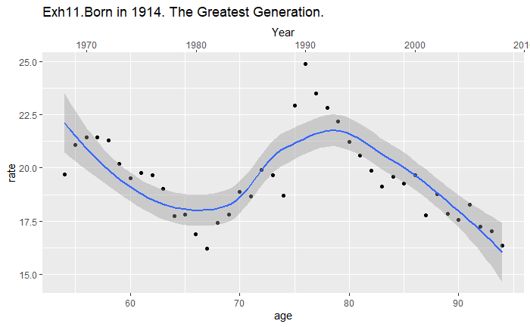

For people born in 1914, a big spike in year 1990 at age of 76.

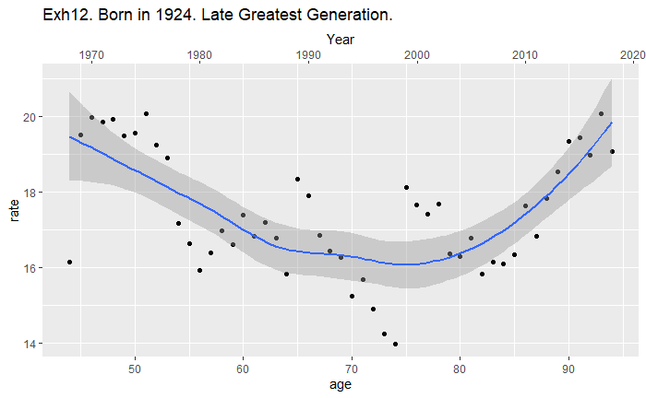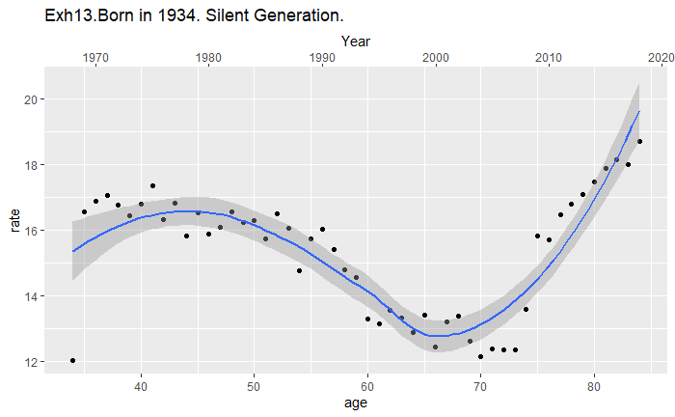

A noticeable drop around year 2000 at age of 65.

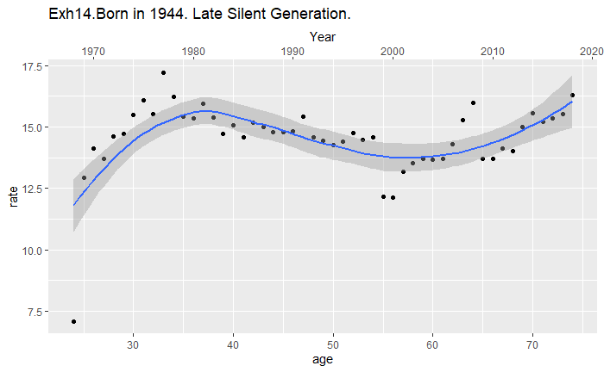

Some spike in early 30th (years - late 70th).

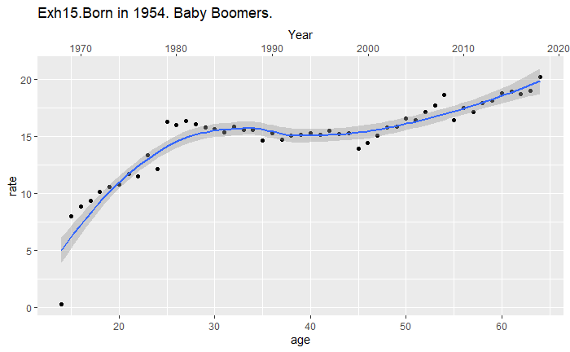

Consistent increase across all years. Year 2000 practically saw no decrease (age of 45).

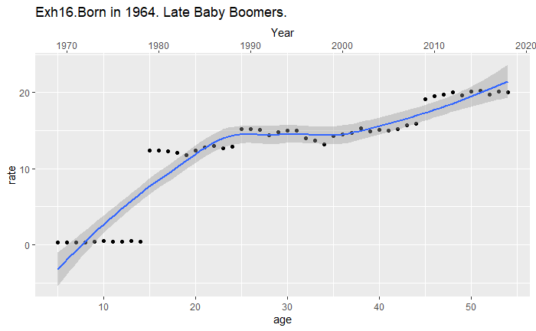

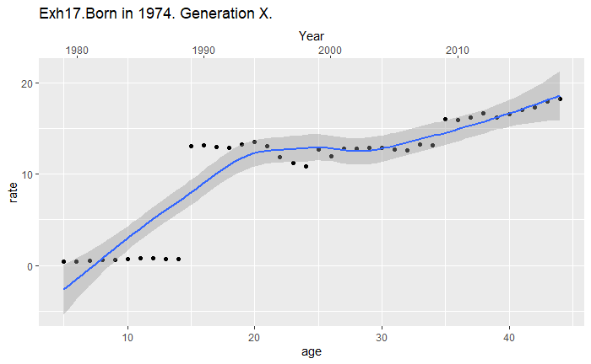

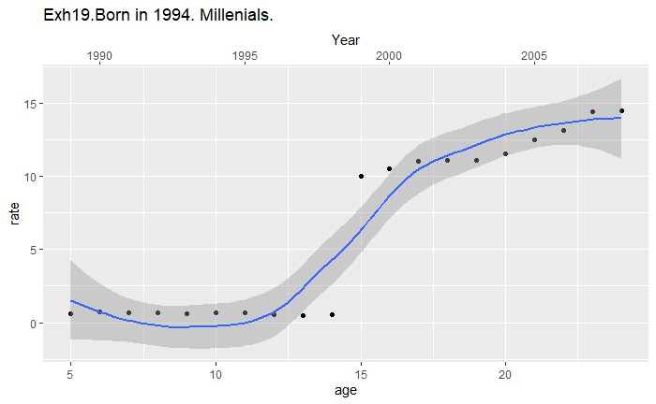

Please note that people born in 1944 have not reached rate of 20 from age 25 to 75, while people born in 1954 reached rate of 20 at age of 60. People born in 1964 reached rate of 20 at age of 50. People born in 1974 at age of 40 and people born in 1984 approach rate of 20 at age of 35. It appears that people born after 1944 die at higher rate from suicide.

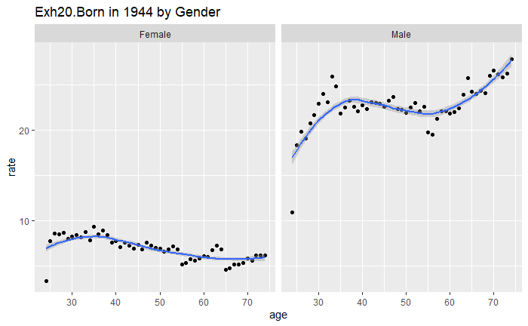

Females born in 1944 had suicide rate peaked at age of 35, while male had rate peaked at age of 35 and then go up again at age of 55.

However, people born in 1954 experienced very different pattern. Females had their rate go up for most of their lives and males reached rate of 30 at age of 60.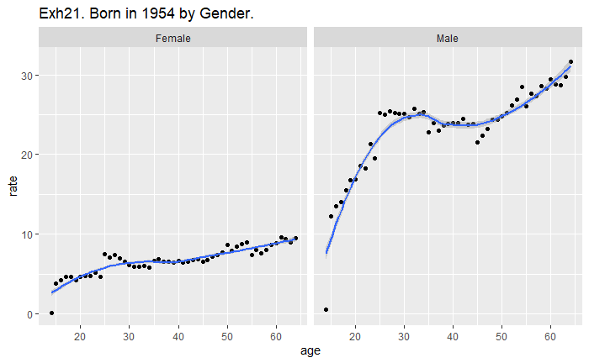

African Americans and whites had roughly the same rate at age of 30 (year 1974), however whites’ suicide rate went up while African American’s rate dropped sharply in the following years (Ext 21A).

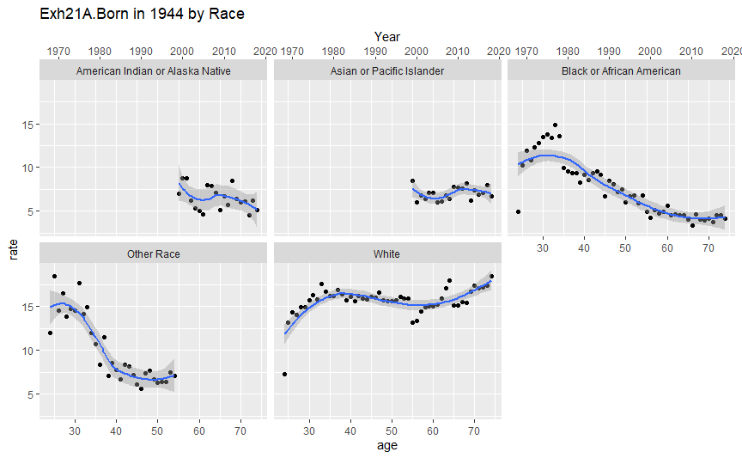Similarly, for people born in 1944, African Americans’ rate peaked at age of 30 (year 1984), While whites’ rate was going up through the whole period.

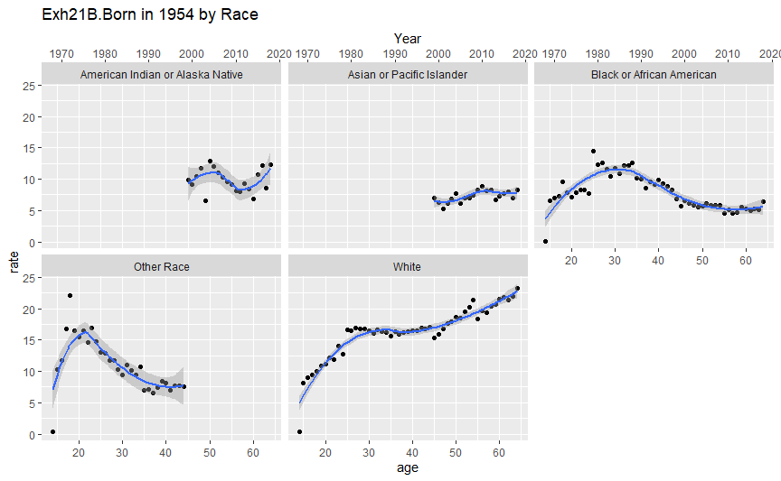

Regions display different patterns as well. While Northeast, Midwest, and South display similar behavior, West is different from them.

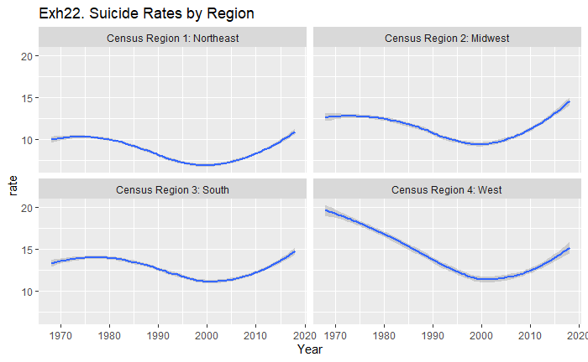

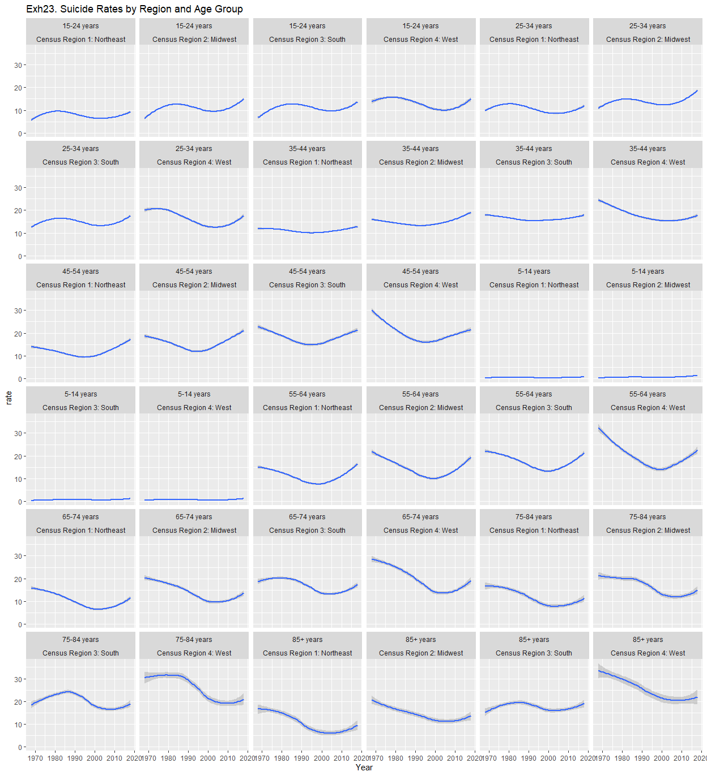

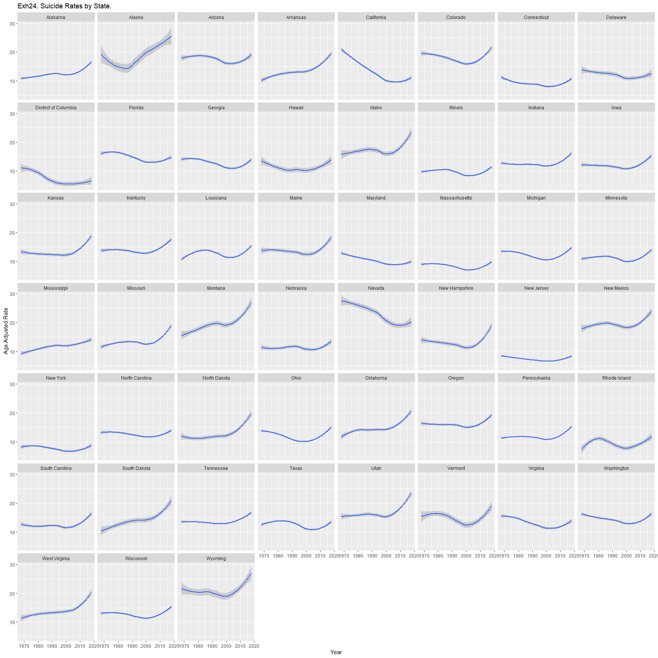

As other variables, states show different behaviors. Some such as California and Nevada saw drops in rates, others, such as Arkansas and South Dakota, saw consistent increases. Others were relatively stable such as New Jersey and North Carolina.

Large Metro Areas have seen smaller increase than Medium Metro or Nonmetro (Exh 24A).

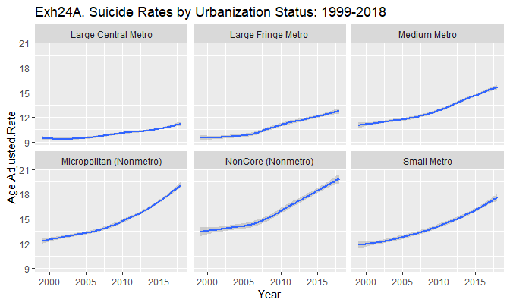

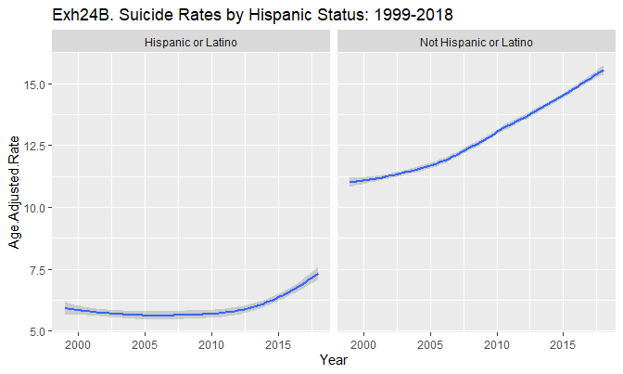

Hispanic status appears to offer favorable suicide profile, which might explain improvement in suicide rates in California and Nevada. Both states have experienced high growth in Hispanic population.

We will review other diseases of despair, such as overdoses. The rates show different pattern = they were growing slow through 80th and early 90th and then just exploded afterwards (Exh25).

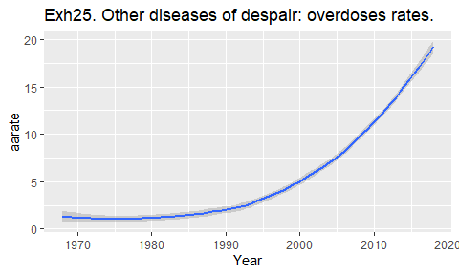

However, when it comes to alcoholic liver disease death rate, these rates display very similar behavior. They were dropping up to early 2000ths and then we up. It seems that alcoholic rates are shifter to the right by a few years from suicide rates (suicide bottomed at year 2000, while alcoholic bottomed at year 2006.

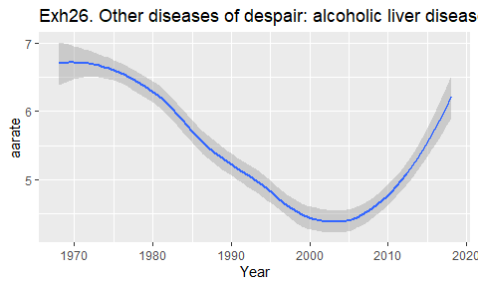

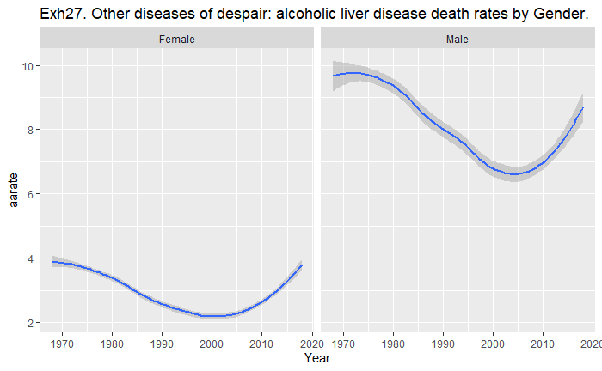

Gender rates for alcoholic disease and suicide also look very similar.

So is race:

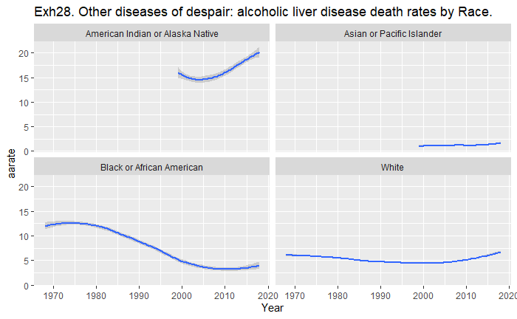

## CDC Mortality Multiple Cause-of-Death Flat File – 2018.

This file does not provide geographical details and as it has only a year worth of data, it does not allow us to look at suicide behavior across of time, however this file still can help us to shed light on some suicide trends.

People who committed suicide were better educated than average person who died in 2018 (46% had some college education for suicide victims 25 years old and over, versus 36% for all people who died in 2018 and were 25 years old or over).

The highest suicide rate was in summer months in contrast to overall deaths that were at highest from October to April.

As we have already seen males accounted for majority of suicides (78%), while males constituted 51% of overall deaths.

# References.

*500 Cities: Local Data for Better Health*. (n.d.). Retrieved from 500 Cities: Local Data for Better Health: https://www.cdc.gov/500cities/index.htm

*AFSP*. (n.d.). Retrieved from AFSP: https://afsp.org/suicide-statistics/

*American Community Survey*. (n.d.). Retrieved from American Community Survey: https://www.census.gov/programs-surveys/acs

Barjasteh-Askari, F. (2019, December 19). *Relationship between suicide mortality and lithium in drinking water: A systematic review and meta-analysis.* Retrieved from Relationship between suicide mortality and lithium in drinking water: A systematic review and meta-analysis.: https://www.ncbi.nlm.nih.gov/pubmed/32056756

Berardelli, I. (2018, Nov 6). *Lifestyle Interventions and Prevention of Suicide*. Retrieved from Lifestyle Interventions and Prevention of Suicide: https://www.ncbi.nlm.nih.gov/pmc/articles/PMC6232529/

*BLS*. (n.d.). Retrieved from BLS: https://www.bls.gov/

*BMJ*. (2019, February 6). Retrieved from BMJ: https://www.bmj.com/content/364/bmj.l94

Bradvik, L. (2018, September 15). *Suicide Risk and Mental Disorders*. Retrieved from Suicide Risk and Mental Disorders: https://www.ncbi.nlm.nih.gov/pmc/articles/PMC6165520/

Cato, V. (2019, Oct 26). *Association between benzodiazepines and suicide risk: a matched case-control study.* Retrieved from Association between benzodiazepines and suicide risk: a matched case-control study: https://bmcpsychiatry.biomedcentral.com/articles/10.1186/s12888-019-2312-3

*CDC*. (2020, April). Retrieved from CDC: https://www.cdc.gov/nchs/pressroom/sosmap/suicide-mortality/suicide.htm

*CDC Wonder*. (n.d.). Retrieved from CDC Wonder: https://wonder.cdc.gov/

*Census*. (n.d.). Retrieved from Census: https://www.census.gov/en.html

Cuchara, B. (2020, Mar). *An 8-Year Retrospective Study on Suicides in Washington, DC.* Retrieved from An 8-Year Retrospective Study on Suicides in Washington, DC.: https://www.ncbi.nlm.nih.gov/pubmed/32000223

Curtain, S. C. (2020, March 6). *QuickStats: Age-Adjusted Suicide Rates,* by Sex and Three Most Common Methods† — United States, 2000–2018.* Retrieved from QuickStats: Age-Adjusted Suicide Rates,* by Sex and Three Most Common Methods† — United States, 2000–2018: https://www.cdc.gov/mmwr/volumes/69/wr/mm6909a7.htm?s_cid=mm6909a7_w

Fonti, V. (2017, March 30). *Feature Selection using LASSO*. Retrieved from Feature Selection using LASSO: https://beta.vu.nl/nl/Images/werkstuk-fonti_tcm235-836234.pdf

Gibbons, R. (2013, April 25). *The statistics of suicide.* Retrieved from NCBI: https://www.ncbi.nlm.nih.gov/pmc/articles/PMC4054543/

*Global status report on alcohol and health, WHO.* (2011). Retrieved from Global status report on alcohol and health, WHO: https://www.who.int/substance_abuse/publications/global_alcohol_report/msbgsruprofiles.pdf

Gradus, J. (2010, July 12). *Acute stress reaction and completed suicide*. Retrieved from Acute stress reaction and completed suicide: https://academic.oup.com/ije/article/39/6/1478/736998

Guillaume, F. (2016, Feb 17). *Disparities in suicide mortality trends between United States of America and 25 European countries: retrospective analysis of WHO mortality database*. Retrieved from Disparities in suicide mortality trends between United States of America and 25 European countries: retrospective analysis of WHO mortality database: https://www.ncbi.nlm.nih.gov/pmc/articles/PMC4756707/

Helbich, M. (2017, Aug 9). *Spatiotemporal Suicide Risk in Germany: A Longitudinal Study 2007–11*. Retrieved from Spatiotemporal Suicide Risk in Germany: A Longitudinal Study 2007–11: https://www.ncbi.nlm.nih.gov/pmc/articles/PMC5550498/

Hoffmire, C. (2020, Feb 24). *Reevaluating Suicide Mortality for Veterans With Data From the VA-DoD Mortality Data Repository, 2000-2010.* Retrieved from Reevaluating Suicide Mortality for Veterans With Data From the VA-DoD Mortality Data Repository, 2000-2010.: https://www.ncbi.nlm.nih.gov/pubmed/32089080

Ilgun, G. (2019, Nov 20). *Individual and socio-demographic determinants of suicide: An examination on WHO countries.* Retrieved from Individual and socio-demographic determinants of suicide: An examination on WHO countries.: https://www.ncbi.nlm.nih.gov/pubmed/31746258

Kaufman, J. (2020, Jan 7). *Effects of increased minimum wages by unemployment rate on suicide in the USA.* Retrieved from Effects of increased minimum wages by unemployment rate on suicide in the USA.: https://www.ncbi.nlm.nih.gov/pubmed/31911542

Klonsky, E. (2017, Jan). *Recent advances in differentiating suicide attempters from suicide ideators.* Retrieved from Recent advances in differentiating suicide attempters from suicide ideators: https://insights.ovid.com/article/00001504-201701000-00004

KTL, S. (2018, Jun 8). *Spatiotemporal clustering of suicides in the US from 1999 to 2016: a spatial epidemiological approach.* Retrieved from Spatiotemporal clustering of suicides in the US from 1999 to 2016: a spatial epidemiological approach.: https://www.ncbi.nlm.nih.gov/pubmed/31177308

Lamis, D. A. (2012 , Mar 28). *Alcohol Use and Suicidal Behaviors among Adults: A Synthesis and Theoretical Model*. Retrieved from Alcohol Use and Suicidal Behaviors among Adults: A Synthesis and Theoretical Model: https://www.ncbi.nlm.nih.gov/pmc/articles/PMC3519287/

Landberg, J. (2008, July 27). *Alcohol and suicide in eastern Europe*. Retrieved from Alcohol and suicide in eastern Europe: https://www.ncbi.nlm.nih.gov/pubmed/18584385

Lee, H. (2020, Feb 25). *Association of long working hours with accidents and suicide mortality in Korea.* Retrieved from Association of long working hours with accidents and suicide mortality in Korea.: https://www.ncbi.nlm.nih.gov/pubmed/32096547

Li, H. (2007, September 18). *Beyond Moran's I: Testing for Spatial Dependence Based on the Spatial Autoregressive Model*. Retrieved from Beyond Moran's I: Testing for Spatial Dependence Based on the Spatial Autoregressive Model: https://onlinelibrary.wiley.com/doi/full/10.1111/j.1538-4632.2007.00708.x

Lynch, F. (2020, Feb 21). *Substance use disorders and risk of suicide in a general US population: a case control study.* Retrieved from Substance use disorders and risk of suicide in a general US population: a case control study.: https://www.ncbi.nlm.nih.gov/pubmed/32085800

Madsen, T. (2018, Aug 14). *Association Between Traumatic Brain Injury and Risk of Suicide*. Retrieved from Association Between Traumatic Brain Injury and Risk of Suicide: https://jamanetwork.com/journals/jama/article-abstract/2697009

Matsubayshi, T. (2020, Feb 21). *Government spending, recession, and suicide: evidence from Japan.* Retrieved from Government spending, recession, and suicide: evidence from Japan.: https://www.ncbi.nlm.nih.gov/pubmed/32079525

McTernan, N. (2018, July 4). *Sage Journals.* Retrieved from International Journal of Social Psychiatry: https://journals.sagepub.com/doi/10.1177/0020764018784624

*National Institute of Mental Health*. (2019, April). Retrieved from National Institute of Mental Health: https://www.nimh.nih.gov/health/statistics/suicide.shtml#part_154968

Pompili, M. (2010, Apr 7). *Suicidal Behavior and Alcohol Abuse*. Retrieved from Suicidal Behavior and Alcohol Abuse: https://www.ncbi.nlm.nih.gov/pmc/articles/PMC2872355/

Richards, J. (2020, March 5). *Association Between Patterns of Alcohol Use and Short-Term Risk of Suicide Attempt Among Patients With and Without Reported Suicidal Ideation.* Retrieved from Association Between Patterns of Alcohol Use and Short-Term Risk of Suicide Attempt Among Patients With and Without Reported Suicidal Ideation.: https://www.ncbi.nlm.nih.gov/pubmed/32142058

Rocha, J. (2019, Nov 25). *Can We Develop a Risk Map for Suicide Rates? An Ecological Study in Portugal.* Retrieved from Can We Develop a Risk Map for Suicide Rates? An Ecological Study in Portugal: https://www.ncbi.nlm.nih.gov/pubmed/31768928

(2018). *Russian Statistical Yearbook.*

*SAMHSA*. (n.d.). Retrieved from SAMHSA: https://www.samhsa.gov/

Sanderson, M. (2019, Dec 14). *Predicting death by suicide using administrative health care system data: Can recurrent neural network, one-dimensional convolutional neural network, and gradient boosted trees models improve prediction performance?* Retrieved from Predicting death by suicide using administrative health care system data: Can recurrent neural network, one-dimensional convolutional neural network, and gradient boosted trees models improve prediction performance?: https://www.ncbi.nlm.nih.gov/pubmed/32056739

Schneider, A. (2010, Nov 5). *Linear Regression Analysis*. Retrieved from Linear Regression Analysis: https://www.ncbi.nlm.nih.gov/pmc/articles/PMC2992018/

Spicer, R. (2000, December). *Suicide Acts in 8 States: Incidence and Case Fatality Rates*. Retrieved from Suicide Acts in 8 States: Incidence and Case Fatality Rates: https://www.ncbi.nlm.nih.gov/pmc/articles/PMC1446422/pdf/11111261.pdf

Spriestersbach, A. (2009, Sep 4). *The Specification of Statistical Measures and Their Presentation in Tables and Graphs. Part 7 of a Series on Evaluation of Scientific Publications*. Retrieved from The Specification of Statistical Measures and Their Presentation in Tables and Graphs. Part 7 of a Series on Evaluation of Scientific Publications: https://www.ncbi.nlm.nih.gov/pmc/articles/PMC2770212/

Toleffsen, I. M. (2012, Feb 14). *The reliability of suicide statistics: a systematic review*. Retrieved from The reliability of suicide statistics: a systematic review: https://www.ncbi.nlm.nih.gov/pmc/articles/PMC3350416/

Xu, J. (2020, January). *Mortality in the United States, 2018*. Retrieved from Mortality in the United States, 2018: https://www.cdc.gov/nchs/products/databriefs/db355.htm

Yamaoka, K. (2020, Feb 18). *Spatial clustering of suicide mortality and associated community characteristics in Kanagawa prefecture, Japan, 2011-2017.* Retrieved from Spatial clustering of suicide mortality and associated community characteristics in Kanagawa prefecture, Japan, 2011-2017.: https://www.ncbi.nlm.nih.gov/pubmed/32070316

Zheng, L. (2020, Feb 20). *Development of an early-warning system for high-risk patients for suicide attempt using deep learning and electronic health records.* Retrieved from Development of an early-warning system for high-risk patients for suicide attempt using deep learning and electronic health records: https://www.ncbi.nlm.nih.gov/pmc/articles/PMC7033212/